Q1 Program to check if year is leap or not using if else statement

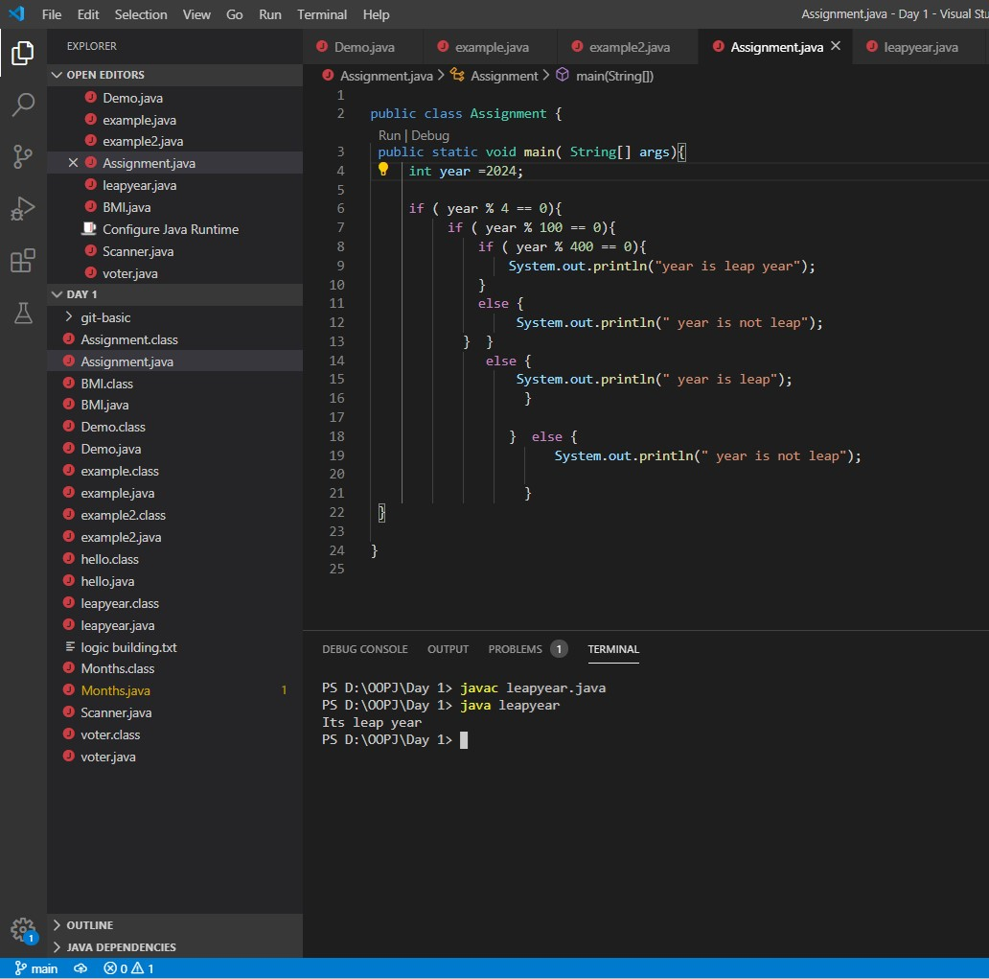

Using switch statement

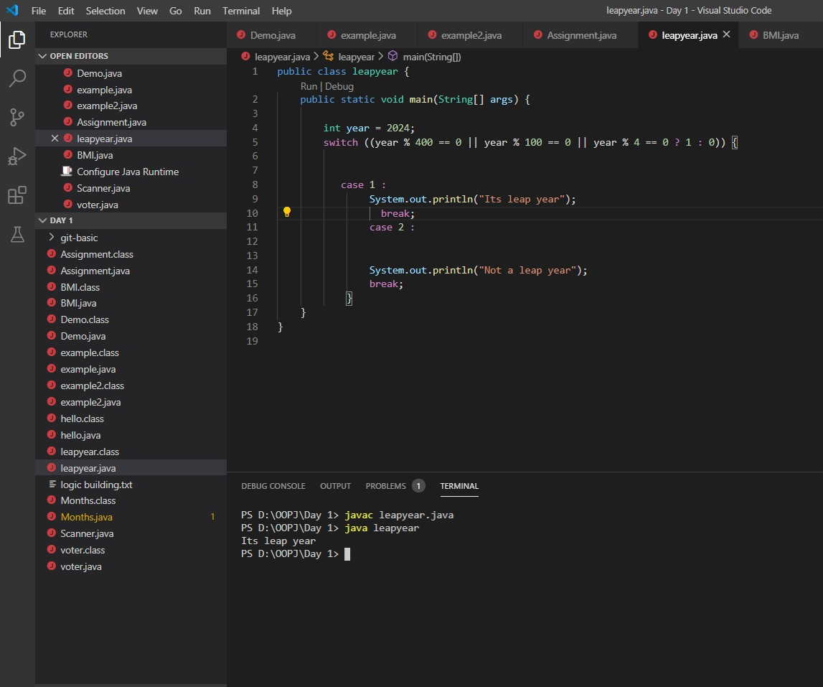

Q 2 BMI index based on there age and height

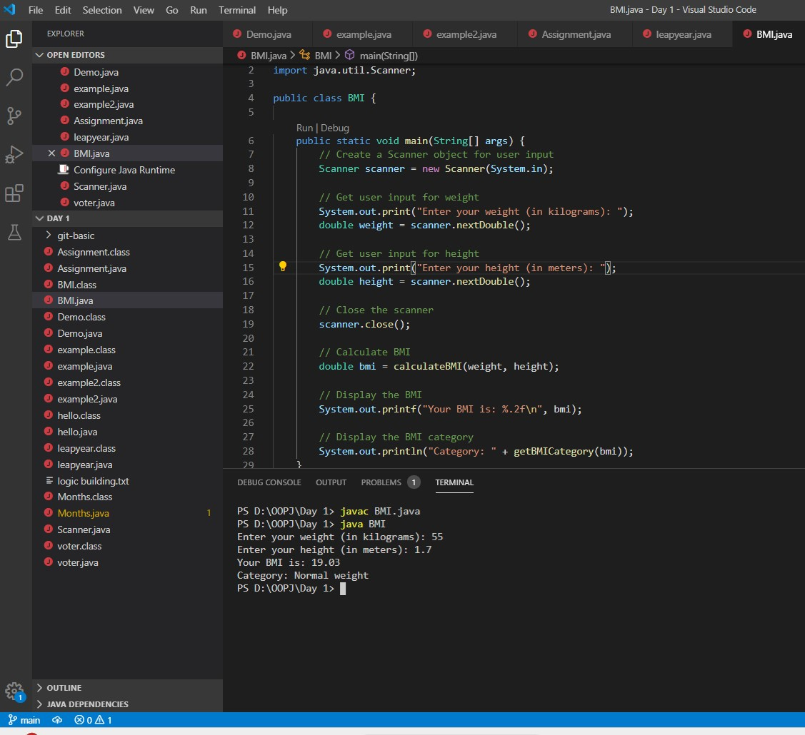

Q 3 Program about if person is eligible for vote or not

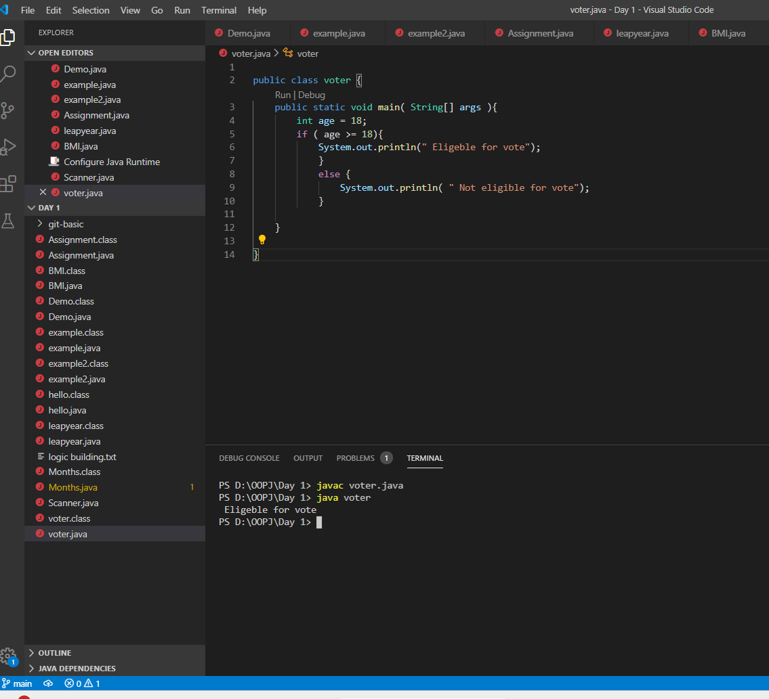

Q4 write a program that takes moths and corresponding season

